6. The Everspring Inn Mass Evictions & Systemic Failures in Seattle’s Tenant Protections

A City-Sanctioned Humanitarian Crisis
In August 2020, during one of the most devastating public health crises in modern history, dozens of residents at the Everspring Inn (8201 Aurora Ave N, Seattle) were forcibly and unlawfully evicted, despite the Seattle eviction moratorium, which explicitly prohibited such actions.

These were not tenants with financial safety nets. They were the sick, the elderly, the disabled, and the working poor, surviving month to month in a rundown motel that had functioned as long-term housing. They were thrown onto the streets with nowhere to go, in the middle of a global pandemic.

This was not just an eviction. It was a state-enabled act of cruelty.

The mass eviction took place shortly after the Seattle Police Department (SPD) issued a Chronic Nuisance Property Declaration against the property’s owner, Myung Ha Kang (Ryan Kang), citing ongoing criminal activity at the motel. Instead of addressing these concerns, Kang weaponized this declaration, lied to tenants, and falsely claimed the City of Seattle itself was evicting them.

Chronology of Complaints & SDCI’s Failures

August 18, 2020 – A Day of Forced Displacement
On August 18, 2020, at least 13 emergency complaints were filed with SDCI, reporting:

- Tenants being forcibly locked out of their rooms.
- Windows boarded up to prevent reentry.
- Water and electricity shut off.
- Armed security guards intimidating and physically removing residents.

Despite the urgency and severity, SDCI immediately marked all complaints as “Admin Closure” or “Voluntary Compliance”labeling them as “JCEO” (Just Cause Evictions “COVID-19-X” with no further action taken.

Key Complaints Filed (All Marked ‘Admin Closure’):
- Complaint #007155-20CP – Reports of a mass eviction in progress, water shut off, windows boarded up, and armed security deployed. SDCI closed the complaint the same day with no investigation.
- Complaint #007945-20CP – Tenants reported being locked out, belongings trapped inside, and forced into the streets. SDCI closed it without action.
- Complaint #007177-20CP – A tenant documented over a year of residency at the motel, provided rental receipts, mail evidence, and proof of long-term habitation—clearly establishing legal tenant rights under Seattle law. SDCI closed the case immediately.
- Complaint #007948-20CP – Reports of exit doors being blocked, windows boarded, and physical intimidation by security personnel. SDCI closed without investigation.
- Complaint #007949-20CP – A sick tenant reported being trapped inside the property with no hot water, afraid to leave because of COVID-19 exposure. SDCI did nothing.

This was not a bureaucratic oversight. It was a deliberate choice to ignore clear violations of Seattle’s Just Cause Eviction Ordinance and the eviction moratorium.

Discrepancies Between SDCI’s Statements & Reality

SDCI’s Claim: "We were not aware of the evictions."
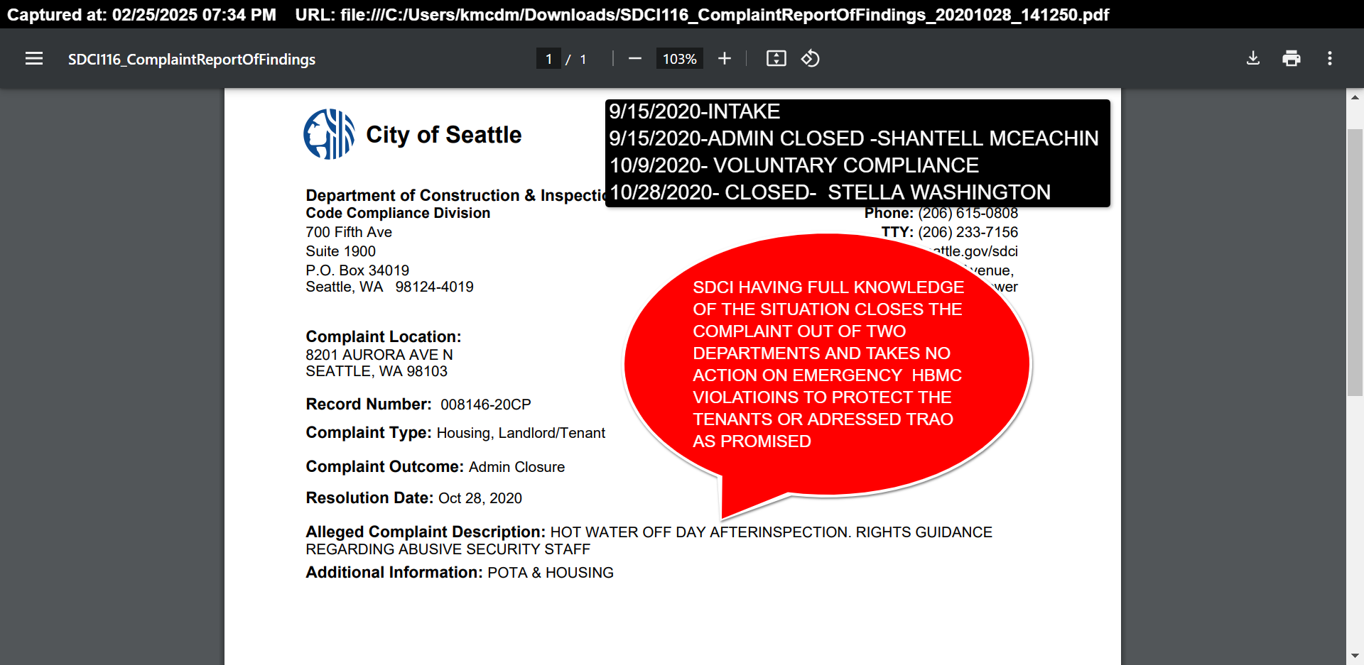
Contradiction:

- Evidence shows multiple complaints were filed on August 18, 2020, explicitly stating that evictions were in progress.
- Complaint #007155-20CP clearly reported the landlord hiring security to prevent tenants from entering, shutting off water, and boarding up windows.
- Despite this, SDCI immediately marked the complaint as ‘Admin Closure’—proving they were aware and chose not to act.

SDCI’s Claim: "The evictions were justified under the nuisance property declaration."
Contradiction:

- The Chronic Nuisance Declaration issued to Ryan Kang in July 2020 did not authorize evictions. It demanded the owner correct issues or face city enforcement.
- Instead, Kang misrepresented the declaration, falsely telling tenants the City was evicting them, and SDCI allowed this lie to go unchecked.
- At no point did SDCI or SPD issue legal eviction notices as required by law.

SDCI’s Claim: "There were safety concerns that required immediate action."
Contradiction:

- If safety was a concern, SDCI should have intervened with inspections and habitability enforcement before the evictions, not ignored tenant reports.
- SDCI’s own records show that they were aware of severe habitability violations but failed to act for years.
- Allowing an illegal eviction did not resolve the safety issues—it left residents in even more dangerous conditions, exposed to homelessness during a pandemic.

SDCI’s Systemic Failures & Violations

1. Violation of Seattle & Washington State Eviction Moratoriums
- At the time, Seattle and Washington State had an eviction ban in place, prohibiting landlords from removing tenants due to nonpayment of rent or lease expiration.
- Exceptions required a court order, yet Ryan Kang did not obtain one.
- SDCI was responsible for enforcing these protections but refused to act.

2. Pattern of Negligence & Non-Enforcement
- Tenant complaints had been filed about Everspring Inn documenting habitability violations, unsafe conditions, and failure to meet minimum rental standards.
- SDCI failed to enforce compliance, Only issuing a

3. Conflict of Interest & Permitting Irregularities
- Despite knowing about severe habitability issues, SDCI later approved construction permits allowing the motel to convert into a hotel.
- This raises questions about regulatory bias and whether SDCI prioritized business interests over tenant protections.

4. Misuse of Public Funds & RRIO Non-Compliance
- King County allocated funding for rapid rehousing at motels like Everspring.
- Under SMC 22.214 (Rental Registration and Inspection Ordinance, RRIO), properties used for long-term housing (30+ days) must meet rental habitability standards.
- SDCI did not enforce RRIO compliance, allowing public funds to be used on substandard, unsafe housing.

The Human Toll: Lives Discarded, Forgotten, and Unprotected
🚨 Where did these tenants go?
🚨 Who among them survived the pandemic?
🚨 How many of them died alone, unhoused, because of this eviction?

The reality is, we don’t know. There were no follow-ups, no support services deployed, no tracking of displaced individuals.

These were people already on the brink of survival—the sick, the elderly, the disabled, the working poor. The City of Seattle abandoned them to die.

This Is Why the Seattle Tenant-Landlord Compliance Authority (STLCA) Must Exist
🔹 SDCI must be stripped of its power over tenant protections.
🔹 The Seattle Tenant-Landlord Compliance Authority (STLCA) must take over enforcement.
🔹 We need real oversight, real accountability, and real protection for tenants.

This is not just policy reform. It is about ending government-sanctioned human rights violations.

🔴 Seattle must decide: protect tenants or continue enabling corruption. 🔴

